#include <bits/stdc++.h>

using namespace std;

#define pb push_back

#define all(a) (a).begin(), (a).end()

using ll = long long;

void solve(){

}

int main(){

std::cin.tie(nullptr);

std::ios_base::sync_with_stdio(false);

int t = 0; cin >> t;

while(t--){solve();}

return 0;

}

std::cin.tie(nullptr);

std::ios_base::sync_with_stdio(false);

int dif = 1e9; = 10000000001

10^8 operations can be done in 1 sec

# Algorithms

Matrix rotation

n = size of matrix

for (i < n)

for(j < n)

m[i][j] = pos actual

m[j][n - 1 - i] = 90 degrees

m[n - 1 - i][n - 1 - j] = 180 degrees rotation

m[n - 1 - j][i] = 270 degrees

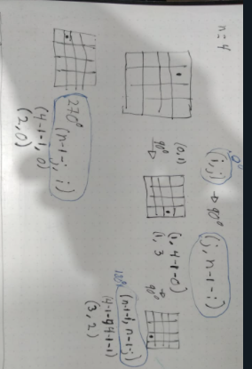

### Kadane´s algorithm

Maximum sum subarray

We are looking for the maximum sum we can get from a contiguous subarray.

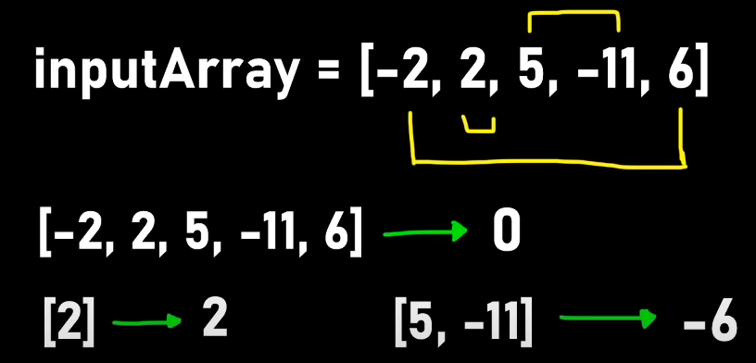 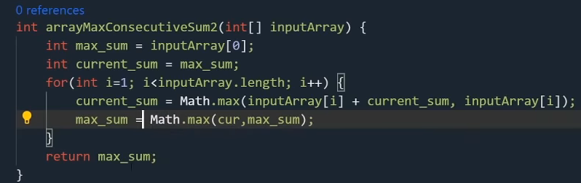

## Dynamic Programming

### Coin Change

¿De cuántas maneras puedes pagar cierta cantidad con un arreglo limitado de monedas?

Tenemos nuestro arreglo de monedas.

Para pagar 1 peso solo tenemos una opción que sería con la moneda de $1.

Si suponemos que solo hay monedas de 1 $

| 0 | 1 | 2 | 3 | 4 | 5 | 6 | 7 | 8 | 9 | 10 | 11 | 12 | 13 | 14 | 15 | 16 | 17 | 18 |
| --- | --- | --- | --- | --- | --- | --- | --- | --- | --- | --- | --- | --- | --- | --- | --- | --- | --- | --- |
| 1 | 1 | 1 | 1 | 1 | 1 | 1 | 1 | 1 | 1 | 1 | 1 | 1 | 1 | 1 | 1 | 1 | 1 | 1 |

Para ir calculando cuando de nuevo los valores al agregar una moneda nueva lo que hacemos es:

Estamos sumando lo que tenemos en nuestra casilla + lo que está en 2 posiciones anteriores.

X[j] += X[j - k];

A nuestra posición le sumamos j(pos) - k(actualCoin)

### Coin Change

Mínimo número de monedas para pagar cierta cantidad.

Tenemos nuestras monedas, y la cantidad a pagar.

### Torre de Piedras

O(nm)

N = cantidad de piedras. M = Resultado de dividir entre 2 el peso total.

Sumamos el peso total de las piedras. Dividimos entre 2. Buscamos las maneras de sumar ese número el tamaño de las piedras que tenemos.

Arreglo de bool X por que solo nos interesa saber si se puede hacer cierta cantidad.

Checamos cuales cantidades podemos hacer con nuestras piedras.

| 0 | 1 | 2 | 3 | 4 | 5 | 6 | 7 | 8 | 9 | 10 | 11 | 12 | 13 | 14 |
| --- | --- | --- | --- | --- | --- | --- | --- | --- | --- | --- | --- | --- | --- | --- |
| 1 | 1 | 0 | 1 | 1 | 0 | 1 | 1 | 1 | 0 | 1 | 1 | 0 | 0 | 1 |

El 14 lo podemos sumar con la de 8+3+3

Y en el otro montón pongo lo restante.

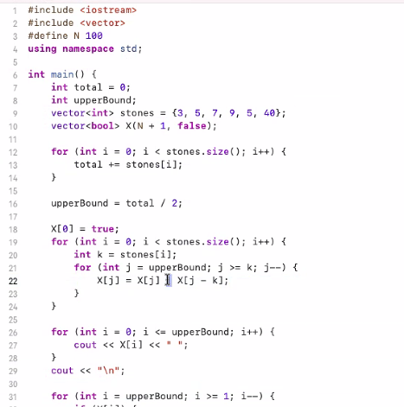

K es nuestra piedra actual.

2do for:

j = upperBound mientras que j >= k

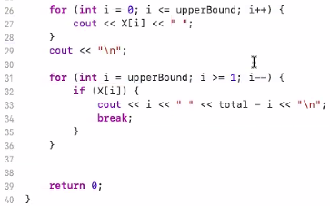

### Optimal Matrix Chain Multiplicación

**Code:**

#include <cstdio>

#include <cstring>

#define N 100

#define oo 1000000

using namespace std;

int A[N + 1];

int X[N + 1][N + 1];

int path[N +1 ][N + 1];

// X[i][j] es minimo numero de operaciones para multiplicar la seccion de i a j.

// Resultado X[0][n-1]

void printSequence(int, int);

int main() {

int n, val;

scanf("%d", &n);

for (int i = 0; i < n; i++) {

scanf("%d %d", &A[i], &A[i + 1]);

}

memset(X, 0, sizeof(X));

for (int len = 1; len <= n - 1; len++) {

for (int i = 1; i <= n - len; i++) {

int j = i + len;

X[i][j] = oo;

for (int k = i; k <= j; k++) {

val = X[i][k] + X[k + 1][j] + (A[i - 1] * A[j] * A[k]);

if (val < X[i][j]) {

X[i][j] = val;

path[i][j] = k;

}

}

}

}

printf("%d\n", X[1][n]);

printSequence(1, n);

printf("\n");

return 0;

}

void printSequence(int a, int b) {

if (a == b) {

printf("A%d", a);

} else {

printf("(");

printSequence(a, path[a][b]);

printf("x");

printSequence(path[a][b] + 1, b);

printf(")");

}

}

## KMP

Pattern searching in a string. String searching.

O(n)

We use the pref func to know which is the Largest Palindromic String.

vector<int> pref(string pattern){

vector<int> lps(pattern.size());

int idx = 0;

for(int i = 1; i < pattern.size();){

if(pattern[i] == pattern[idx]){

lps[i] = idx + 1;

i++;

idx;

}else{

if(idx != 0){

idx = lps[idx - 1];

}else{

lps[i] = 0;

i++;

}

}

}

return lps;

}

int KMP(string t, string pattern){

vector<int> lps = pref(pattern);

int i = 0, j = 0;

while(i < t.size() && j < pattern.size()){

if(t[i] == pattern[j]){

i++;

j++;

}else{

if(j != 0) j = lps[j - 1];

else i++;

}

}

if(j == pattern.size()) return true;

else return false;

}

# Strings

**substr(pos, len)**

**pos:** Position of the first character to be copied as a substring.

**len:** Number of characters to include in the substring.

You can use substr to create prefixes and suffixes of string.

**Example:**

for(int i = 0; i < n; i++){

bool ok = false;

for(int j = 0; j < s[i].size(); j++){

string pref = s[i].substr(0, j);

string suff = s[i].substr(j, s[i].length() - j);//Incluyendo j agarra s[i.length - j]

if(M[pref] && M[suff]) ok = true;

}

cout << ok;

}

### String Hashing

**B, M** Tienen que ser primos.

**B** tiene que ser mayor al valor de de nuestras letras.

En **powB** guardamos las potencias de B.

#include <bits/stdc++.h>

using namespace std;

using ll = long long;

ll M = pow(10, 9) + 7;

int B = 157;

int v(char c){

return c -'a' + 1;

}

void solve(){

string s, p;

cin >> s >> p;

int n = s.size(), m = p.size();

vector<ll> powB(n + 1), H(n + 1), Ht(m + 1);

H[0] = 0;

Ht[0] = 0;

powB[0] = 1;

for(int i = 0; i < n; i++){//Calculate Hashes.

H[i + 1] = (H[i] * B + v(s[i])) % M;

powB[i + 1] = (powB[i] * B) % M;

}

for(int i = 0; i < m; i++){

Ht[i + 1] = (Ht[i] * B + v(p[i])) % M;

powB[i + 1] = (powB[i] * B) % M;

}

int ans = 0;

for(int i = 0; i + m <= n; i++){

int res = ((H[i + m] - H[i] * powB[m]) % M + M ) % M;

if(Ht.back() == res){

ans += 1;

}

}

/*cout << "Hashes :\n";

for(int i = 0; i < n; i++) cout << H[i] << " ";

cout << "\n";

for(int i = 0; i < m; i++) cout << Ht[i] << " ";*/

cout << ans;

}

# Data structures

# STL

## Vector

### Sort

you to include <algorithm>

sort(your_array.begin(),your_array.end());

This will sort through your elements in O(nlogn)

### binary_search

To use binary search we need to have our array sorted.

binary_search(your_array.begin(),your_array.end(),variable_to_be_find);

It returns a boolean.

O(logn)

### lower_bound()

Return an iterator pointing to the first element in the range [first, last) which has a value not less than val. This means that the function returns an iterator pointing to the next smallest number just greater than or equal to that number. If there are multiple values that are equal to val, lower_bound() returns the iterator of the first such value.

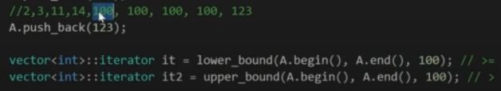

You can use it to know how far is a number from a value.

for(int i = 1; i <= n; i++){

if(N[i] >= i) continue;//Does not satisfy inequality.

res += (long long)(lower_bound(v.begin(), v.end(), N[i]) - v.begin());//Search how far is N[i] from the start of the vector v.

v.push_back(i);//Make list storing all i that appeats before j.

}

## Set

set<data type> name;

Save unique elements. Values are stored in a specific order.

unordered_set<data type> name

insert()

erase()

Printing a set:

for (auto it = myset.begin(); it !=

myset.end(); ++it)

cout << ' ' << *it;

## Map

Each element has a key value and a mapped value. We use the key to access the mapped value.

map<int, int> order

insert(pair<int, int>(1, 40));

Erasing elements up to a certain value:

gquiz2.erase(gquiz2.begin(), gquiz2.find(3));

Ways of printing a map:

**Range-based for loops**

for (auto const &pair: m) {

std::cout << "{" << pair.first << ": " << pair.second << "}\n";

}

**Using an iterator**

for (auto it = m.cbegin(); it != m.cend(); ++it) {

std::cout << "{" << (*it).first << ": " << (*it).second << "}\n";

}

**Overloading <<**

ostream &operator<<(std::ostream &os, const std::unordered_map<K, V> &m) {

for (const std::pair<K, V> &p: m) {

os << "{" << p.first << ": " << p.second << "}\n";

}

return os;

}

**Traverse map in reverse direction**

map<int, int>::reverse_iterator it;

for (it = mp.rbegin(); it != mp.rend(); it++) {

cout << "(" << it->first << ", " << it->second << ")" << endl;

}

**Search if a key is in a map**

if(mp.find(b) != mp.end()){} mp[b]++;

# Trees

### Traversals:

void **preorder**(Nodo* nodo){

if(nodo == nullptr) return;

cout << nodo->val << “ “;

preorder(nodo->left);

preorder(nodo->right);

}

void **order**(Nodo* nodo){

if(nodo == nullptr) return;

order(nodo->left);

cout << nodo->val << “ “;

order(nodo->right);

}

void **postorder**(Nodo* nodo){

if(nodo == nullptr) return;

postorder(nodo->left);

postorder(nodo->right);

cout << nodo->val << “ “;

}

Levelorder

int **altura**(TreeNode* root){

if(root == nullptr) return 0;

int altura_izq = 1 + altura(root->left);

int altura_der = 1 + altura(root->right);

return max(altura_izq, altura_der);

}

void **printCurrentLevel**(TreeNode *root, int level){

if(root == nullptr) return;

if(level == 1) cout << root->val << “ “;

else if(level > 1){

printCurrentLevel(root->left, level - 1);

printCurrentLevel(root->right, level - 1);

}

}

void **levelTraversal**(TreeNode* root){

k = altura(root);

for(int i = 1; i <= k; i++) printCurrentLevel(root, i);

}

## Binary Tree

Implementación:

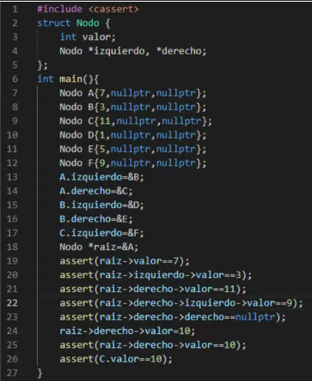

#### Symmetric

bool **isMirror**(TreeNode * t1, TreeNode* t2){

if(t1 == nullptr && t2 == nullptr) return true;

if(t1 == nullptr || t2 == nullptr) return false;

return (t1->val == t2->val) &&

isMirror(t1->left, t2->right) &&

isMirror(t1->right, t2->left);

}

bool **isMirror**(TreeNode * left, TreeNode* right){

if(left == nullptr || right == nullptr) return left == right;

if(left->val != right->val) return false;

return isMirror(left->left, right->right) &&

isMirror(left->right, right->left);

}

#### PathSum

bool haspathSum(TreeNode* root, int targetSum, int pathSum){

if(root == nullptr) return false;

int a = targetSum;

int sum = pathSum + root->val;

if(root->left == nullptr && root->right == nullptr)

return targetSum == sum;

bool ans_left = haspathSum(root->left, a, sum);

bool ans_right = haspathSum(root->right, a, sum);

return ans_left || ans_right;

}

## Heap Tree

Easy and fast implementation can be done with a priority_queue.

### Priority_queue

A priority queue in c++ is a type of container adapter, which processes only the highest priority element, i.e. the first element will be the maximum of all elements in the queue, and elements are in decreasing order.

Declaration:

#include <queue>

priority_queue<int> Q;

For a priority queue in ascending order:

priority_queue<int, vector<int>, greater<int>> Q;

<https://www.geeksforgeeks.org/priority-queue-in-cpp-stl/>

Note: The above syntax may be difficult to remember, so in case of numeric values, we can multiply the values with -1 and use max heap to get the effect of min heap.

We can multiply tha data that we want to store in the priority queue * -1

Then when we retrieve the data we can simply multiply by - 1. cout << pq.top()*-1;

Example:



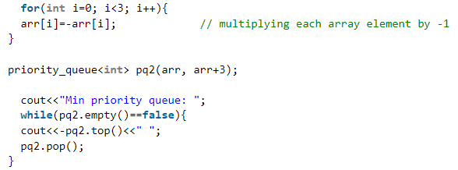

Another way could be using a multiset. The multiset implements a BST.

## Segment Tree

It helps us answer questions of intervals.

Min number in an interval.

Max number in an interval.

Sum of an interval.

you could answer these questions using a matrix but it would take O(n^2) to build the matrix.

O(n) to build the segment tree.

Answer in O(Log n)

A segment tree is a binary tree.

The elements of the array will be the leafs of the binary tree.

To build the tree split the array in half.

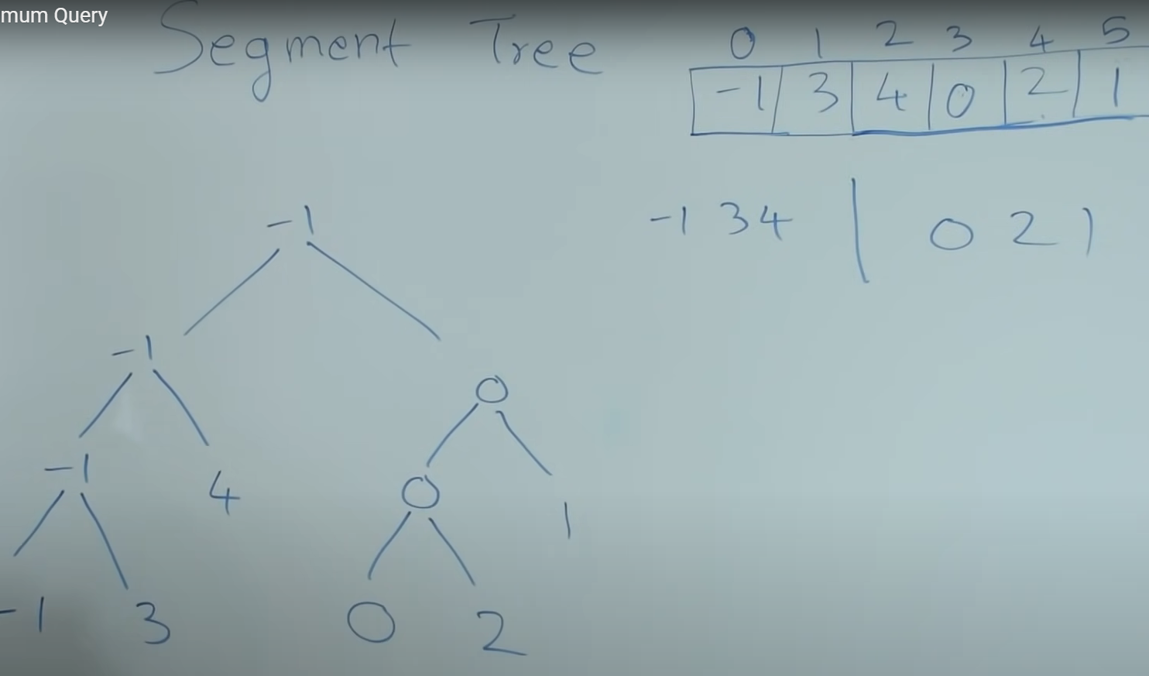

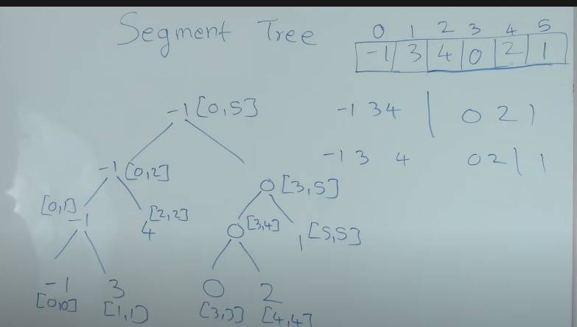

Does my query range overlap the range of the current node?

**Partial overlap:** If the overlap is partial then we are going to keep searching for both sides of the subtree.

**Total overlap:** Stop. When the current node interval is contained on the query interval then this is one part of the answer. We return the value of this node.

**No overlap:** Stop and return a really big number. In this video he returned a max because it is the opposite thing of what we are asking.

The size of the vector<int> tree:

1. if(n == a power of two) tree.resize(( 2 * n) - 1);
2. else{//Encontramos la siguiente potencia de dos.

int next = pow(2, ceil(log(n) / log(2)));//Get next power of two.

tree.resize((2 * next) - 1);

}

Function to build the tree from an array.

build(0, n - 1, 0);

x = current node, lx = left of current interval, rx = right of current interval.

void build(int l, int r, int x){

if(l == r){//Leaf node.

tree[x] = a[l];

return;

}

int m = (l + r) / 2;//Mid

build(l, m, (x * 2) + 1);//Left subtree

build(m + 1, r, (x * 2) + 2);//Right subtree

tree[x] = tree[(x * 2) + 1] + tree[(x * 2) + 2];//Actual node is sum of both children.

}

Function to calculate a query

sum(i, v - 1, 0, 0, n - 1);

l and r are the interval of the query.

int sum(int l, int r, int x, int lx, int rx){

//if(l > r) return 0;

if(lx >= l && rx <= r) return tree[x];

//Check if you are including the r element of not.

if(lx > r || l > rx) //lx > r || l > rx will include the r element on the sum.

return 0;

int m = (lx + rx) / 2;

int s1 = sum(l, r, (2 * x) + 1, lx, m);

int s2 = sum(l, r, (2 * x) + 2, m + 1, rx);

return s1 + s2;

}

Function to make an update

set(i, v, 0, 0, n - 1);

i = pos of the Tree array to update. v value

void set(int i, int v, int x, int lx, int rx){

if(lx == rx) {

tree[x] = v;

return;

}else{

int m = (lx + rx) / 2;

if(i <= m) set(i, v, (x * 2) + 1, lx, m);

else set(i, v, (x * 2) + 2, m + 1, rx);

tree[x] = tree[(x * 2) + 1] + tree[(x * 2) + 2];

}

}

## BST

A binary search tree (BST), a special form of a binary tree, satisfies the binary search property:

1. The value in each node must be greater than (or equal to) any values stored in its left subtree.
2. The value in each node must be less than (or equal to) any values stored in its right subtree.

Los valores del subarbol de la derecha deben ser mayores o igual que su padre y los de la izquierda menor o igual que su padre.

#### Valid BST

class Solution {

private:

bool isBST(TreeNode* root, long long min, long long max){

if(root == nullptr) return true;

long long value = root->val;

if(value < min || value > max) return false;

bool ans_izq = isBST(root->left, min, value - 1);

bool ans_der = isBST(root->right, value + 1, max);

return ans_izq && ans_der;

}

public:

bool isValidBST(TreeNode* root) {

long long min = numeric_limits<int>::min();

long long max = numeric_limits<int>::max();

return isBST(root, min, max);

}

};

If we do inorder traversal, we can get the data from the tree in ascending order.

We are going to use a stack to save the data from least to greatest.

**Operations**

#### Search

TreeNode* searchBST(TreeNode* root, int val) {

if(root == nullptr) return nullptr;

if(root->val == val) return root;

if(val < root->val) return searchBST(root->left, val);

return searchBST(root->right, val);

}

Si estamos en el nodo que buscamos, lo regresamos. Si el valor a buscar es menor que el valor de nuestro nodo entonces buscamos por la izquierda.

Buscamos por la derecha.

#### Insert

TreeNode* insertIntoBST(TreeNode* root, int val) {

if(root == nullptr) return new TreeNode(val);

if(val < root->val) root->left = insertIntoBST(root->left, val);

else root->right = insertIntoBST(root->right, val);

return root;

}

#### KTH largest

**class** KthLargest {

**private**:

struct Node{

int value;

Node* left, right;

}

Node* delete_min(Node* root){

Node* parent = nullptr;

Node* node = root;

while(node->left != nullptr){//Mientras no lleguemos al final

parent = node;

node = node->left;

}

Node* replacement = node->right;

Node* new_root;

if(parent == nullptr) new_root = replacement;//We are in the root.

else {

parent->left = replacement;

new_root = root;

}

delete node;

return new_root;

}

int get_min(Node* root){

Node* node = root;

while(node->left != nullptr)

node = node->left;

return node->value;

}

Node* add(Node* root, int value){

if(root == nullptr) return new Node{value, nullptr, nullptr};

if(value < root->value) root->left = add(root->left, value);

else root->right = add(root->right, value);

return root;

}

Node* root = nullptr;

int size = 0, k;

**public**:

KthLargest(int k, vector<int>& nums) {

k = k;

for(int i = 0; i < nums.size(); i++){

root = add(k, nums[i]);

size++;

if(size > k){

root = delete_min(root);

size--;

}

}

}

int add(int val) {

root = add(root, val), size++;

if(size > k) root = delete_min(root), size--;

int kth = get_min(root);

return kth;

}

};

* Your KthLargest object will be instantiated and called as such:

* KthLargest* obj = new KthLargest(k, nums);

* int param_1 = obj->add(val);

# Gráficas

### Representación

**Matriz de Adyacencia**

Consulta O(1).

Espacio O(n^2).

Calcular el grado O(n).

Encontrar vecino O(n).

**Lista de adyacencia**

Espacio O(n + m).

Calcular el grado O(1).

Encontrar vecino O(vecinos).

Saber si dos vértices estan conectados O(vecinos).

## BFS

**O(V + E).** En Adjacency List.

O(v * E). En Adjacency Matrix.

1.Agrega un vértice a la cola.

2. Mientras la cola no este vacía.

1. Selecciona el siguiente vértice en la cola.
2. Agrega todos sus vecinos a la cola (que no hayan sido agregados).
3. Elimina de la cola.

**void BFS**(vector<vector<int>>& Graph, int start, vector<bool> &visited) {

queue<int> q;//Inicializamos nuestra cola.

q.push(start), visited[start] = true;//Le agregamos el nodo start, le ponemos que lo visitamos.

while (!q.empty()) {//Mientras la cola no este vacia.

int node = q.front();//Agarramos el valor del nodo.

for (int neighboor : Graph[node]) {//Recorremos los vecinos del nodo actual.

if (!visited[neighboor])//Si no lo hemos visitado.

q.push(neighboor), visited[neighboor] = true;//Agregamos los vecinos a la cola y ponemos que ya los visitamos.

}

q.pop();//Sacamos el nodo de la cola.

}

}

## DSU

Te permite agregar una arista entre dos vértices.

Determinar si dos vértices pertenecen a la misma componente.

Cada árbol es un componente.

Id componente es la raíz del árbol.

Guardar para cada vértice su papá

Encontrar componente de A:

-Visitar padres hasta encontrar la raíz O(Altura).

Unir A y B.

* Encontrar raíz de A O(Altura).
* Encontrar la raíz de B O(Altura).
* Padre[raíz de A] = raíz de B O(1).

### DSU

## 

**Code:**

struct DSU {

vector<int> P;

DSU(int N) : P(N) { for(int i = 0; i < N; i++) P[i] = i; }

int find(int x) { return P[x] == x ? x : find(P[x]); }

void merge(int x, int y) { P[find(x)] = find(y); }

};

### Union by Rank

O (Log n)

Adjunta la componente más chica a la más grande. Cuando tienen la misma altura, conecta la componente de x a y.

Observación 1:

Si altura(A) > altura(B)

Podemos conectar B hacia A y altura(A) no cambia.

Observación 2:

Si altura(A) == altura(B)

altura(A) aumenta en 1.

**Code:**

struct DSU {

vector<int> P, H;

DSU(int N) : P(N), H(N, 0) { for(int i = 0; i < N; i++) P[i] = i; }

int find( int x ) { return P[x] == x ? x : find(P[x]); }

void merge(int x, int y) {

int raiz_x = find(x);

int raiz_y = find(y);

if( H[raiz_x] > H[raiz_y] ) swap(raiz_x, raiz_y);

P[raiz_x] = raiz_y;

if( H[raiz_x] == H[raiz_y] ) H[raiz_y]++;

}

};

### Path Compression

O(log N) amortized.

No pasa nada si lo recorremos todo una vez, el problema es recorrerlo todo en cada consulta.

Todos los vértices que recorramos, redirigir a root.

**Code:**

struct DSU {

vector<int> P;

DSU( int N ) : P(N) { for(int i = 0; i < N; i++) P[i] = i; }

int find( int x ) { return P[x] == x ? x : P[x] = find(P[x]); }

void merge( int x, int y ) { P[find(x)] = find(y); }

};

## Dijkstra

O(E log E)

Distancias positivas.

Usamos multiset para procesar las aristas con menor peso.

Considerar eventos “Llegué a un vértice”

-Tiempo de llegada

-Vértice de llegada

Procesar eventos en orden de tiempo

-Revisar que sea un vértice inexplorado

-Usar aristas para agregar nuevos eventos

**Code:**

#include <limits>

#define INF LLONG_MAX

struct Edge { long long to, w; };

bool operator <(const Edge& a, const Edge& b) { return a.w < b.w; }

int main() {

std::ios_base::sync_with_stdio(0);

std::cin.tie(0);

long long n = 0, m = 0;

std::cin >> n >> m;

std::vector<std::vector<Edge>> g(n + 1);

long long a = 0, b = 0, c = 0;

Edge aux;

for (int j = 0; j < m; j++){ //Read the graph.

std::cin >> a >> b >> c; // a is from.

aux.to = b;

aux.w = c;

g[a].push_back(aux); // One way graph.

}

std::multiset<Edge> edges;

std::vector<long long> Dist(n + 1, INF); //Initalize distances in INF.

edges.insert({ 1, 0 });

while (!edges.empty()) { //While there are edges.

auto [node, dist] = *edges.begin();

edges.erase(edges.begin());

if (Dist[node] != INF) continue;

Dist[node] = dist;

for (auto edge : g[node]) //We traverse the neighbors of the current node

edges.insert({ edge.to, edge.w + dist });

}

for (unsigned int i = 1; i < n + 1; i++)

std::cout << Dist[i] << " ";

}

## MST

### Prim

O(N Log N).

Empezamos a recorrer el árbol desde el primer vértice y luego, agarramos la menor que sale de todo el arbol.

**Code:**

struct Edge { int to = 0, weight = 0; };

//Sobrecarga de operadores.

bool operator <(const Edge& a, const Edge& b) { return a.weight < b.weight; }

int main() {

int n = 0, m = 0, a = 0, b = 0, c = 0;

cin >> n >> m;

vector<vector<Edge>> Aristas(n + 1, vector<Edge>(n + 1));

for (int i = 0; i < n; i++) { //Reading from, to, weight.

cin >> a >> b >> c;

Edge edge; // Instantiate Edge object..

edge.to = b; edge.weight = c;

Aristas[a][b] = edge;

edge.to = a;

Aristas[b][a] = edge;//Two ways roads.

}

// Multiset to have always the next smallest edge.

multiset<Edge> edges; vector<bool> vis(n + 1, false);

long long ans = 0;

edges.insert({ 1, 0 }); // Initialize edges.

while (!edges.empty()) { // Mientras haya vértices.

auto [node, w] = *edges.begin(); //Access the cheaper road.

edges.erase(edges.begin()); //Eliminate the cheapest because we already processed it.

if (vis[node]) continue; //Si ya lo visitamos, continue.

ans += w; //Actualize the minimum weight of the graph.

vis[node] = true; //Visited

for (Edge e : Aristas[node]) edges.insert(e); //Add the edges connected to the actual node.

}

cout << ans;

return 0;

}

### Kruskal

Vamos agarrando las aristas más pequeñas, si no forman ciclos.

Para ver si forman un ciclo, usamos DSU.

O(V + ElogV).

E log v para ordenar aristas. V del dsu.

**Code:**

struct DSU{

std::vector<int> P;

DSU(int N) : P(N) {

for (int i = 0; i < N; i++)

P[i] = i;

}

int find(int x) {//Te regresa tu componente

return P[x] == x ? x : find(P[x]);

}

void merge(int x, int y) {

P[find(x)] = find(y);

}

};

struct Edge{

int w, from, to;

};

bool operator <(const Edge& a, const Edge& b) { return a.w < b.w; }

int main() {//n vertex and m edges.

std::ios_base::sync_with_stdio(0);

std::cin.tie(0);

int n, m, a, b, c, k = 0;

std::cin >> n >> m;

std::vector<Edge> Edges;

Edge edge;

for (int i = 0; i < m; i++){

std::cin >> a >> b >> c;

edge.from = a;

edge.to = b;

edge.w = c;

Edges.push_back(edge);

}

sort(Edges.begin(), Edges.end());//Ordenamos las aristas de menor a mayor.

DSU dsu(n + 1);

long long ans = 0;

for(Edge e: Edges)//Recorremos todos las aristas.

if (dsu.find(e.from) != dsu.find(e.to)) { //Si la componente de from no es igual a to.

dsu.merge(e.from, e.to);

k++;

ans += e.w;

}

if(k == n - 1) std::cout << ans;

else std::cout << "IMPOSSIBLE";

return 0;

}*/

## Bellman Ford

O(V * E)

Acepta números negativos.

//for de 0 a v - 1 para recorres los vertices

//for anidado de 0 que va a pasar por toda tu lista de adyacencia.

//Mínimo entre tu distancia actual o la distancia en a + el peso.

**Code:**

#include <iostream>

#include <vector>

#include <algorithm>

#define INF 100000000000LL

using namespace std;

struct Edge{

int from, to, weight;

};

int main(){

std::ios_base::sync_with_stdio(0);

std::cin.tie(0);

short n = 0, m = 0;

int a = 0, b = 0, c = 0;

cin >> n >> m;

vector<Edge> edges(m);

for(int i = 0; i < m; i++){

cin >> a >> b >> c;

edges[i] = { a, b, c};

}

vector<int> Dist(n + 1, INF);

Dist[0] = 0;//El primer vertice nos cuesta 0.

for( int i = 0; i < n - 1; i++){//Por cada vertice.

for(int j = 0; j < m; j++ ){//Recorres sus aristas.

int from = edges[j].from; //From

int to = edges[j].to; //To

int weight = edges[j].weight;

if(Dist[from] != INF){//Si de donde salimos no es INF.

//Actualizamos Dist[to]

Dist[to] = min(Dist[to], Dist[from] + weight);//min(a donde vamos y de donde salimos + el peso)

}

}

}

//Check for cycles

/*for(int i = 0; i < edges.size(); i++){

int u = edges[i].from;

int v = edges[i].to;

if(Dist[u] != INF && Dist[v] > Dist[u] + edges[i].weight){//Si encontramos otra distancia menor es porque hay un ciclo

cout << "There is a cycle\n";

break;

}

}*/

for(int i = 1; i <= n; i++)

cout << Dist[i] << " ";

return 0;

}

## Floyd Warshall

O(V^3)

Nos da todas las distancias a todos los demás vértices.

**Code:**

#include <iostream>

#include <vector>

using namespace std;

#define INF 10000000000000LL

int main() {

int q = 0, n = 0, m = 0, a = 0, b = 0, c = 0;

cin >> n >> m >> q;

vector<vector<long long>> Matrix(n + 1, vector<long long> (n + 1, INF));

for (int i = 1; i <= n; i++)

Matrix[i][i] = 0;

for (int i = 0; i < m; i++) {

cin >> a >> b >> c;

if (Matrix[a][b] > c) {

Matrix[a][b] = c;

Matrix[b][a] = c;

}

}

for (int i = 1; i <= n; i++){//El origen

for (int j = 1; j <= n; j++){//De donde voy

for (int k = 1; k <= n; k++) {//A donde

if(Matrix[j][k] > Matrix[j][i] + Matrix[i][k])

Matrix[j][k] = Matrix[j][i] + Matrix[i][k];

}

}

}

for (int i = 0; i < q; i++){

cin >> a >> b;

Matrix[a][b] != INF ? cout << Matrix[a][b] << "\n" : cout << "-1\n";

}

return 0;

}

## DFS

void dfs(int x, vector<vector<int>> &g, vector<bool> &vis){

vis[x] = true;

for(int y : g[x]){

if(y == x) continue;

if(!vis[y]) dfs(y, g, res);

}

}

## Topo Sort

**O(V + E)**

Node A goes before node B. DAG.

Code:

vector<bool> vis, rStack;

vector<vector<int>> g;

vector<int> ans;

bool cycle = false;

bool dfs(int);

for(int i = 1; i <= n; i++){

if(!vis[i]) if(dfs(i)) break;

}

if(cycle){

cout << "IMPOSSIBLE\n";

return 0;

}

reverse(ans.begin(), ans.end());

for(int i = 0; i < ans.size(); i++) cout << ans[i] << " ";

return 0;

bool dfs(int x){

vis[x] = true;

rStack[x] = true;

for(int y : g[x]){

if(!vis[y])

if(dfs(y)) return true;

if(rStack[y]){

cycle = true;

return true;

}

}

rStack[x] = false;

ans.push_back(x);

return false;

}

## Strongly Connected Components

### Tarjan

### Kosaraju

1. Perform DFS traversal of graph. Push node to Stack before returning.
2. Find the transpose graph by reversing the edges.
3. Pop nodes one by one from stack and again do DFS on modified graph.(Keep popping nodes). Each successful DFS gives 1- SCC.

**Code:**

#include <bits/stdc++.h>

using namespace std;

const int maxN = 1e5+1;

bool vis[maxN];

int N, M, rt[maxN];

vector<int> ord, comp, G[maxN], GR[maxN];

void dfs1(int u){

vis[u] = true;

for(int v : G[u])

if(!vis[v])

dfs1(v);

ord.push_back(u);

}

void dfs2(int u){

vis[u] = true;

comp.push_back(u);

for(int v : GR[u])

if(!vis[v])

dfs2(v);

}

int main(){

scanf("%d %d", &N, &M);

for(int i = 0, a, b; i < M; i++){

scanf("%d %d", &a, &b);

G[a].push_back(b);//Normal Graph

GR[b].push_back(a);//Transpose Graph

}

for(int i = 1; i <= N; i++)//1st step

if(!vis[i])

dfs1(i);

int K = 0;

fill(vis+1, vis+N+1, false);//Vis equals to false.

reverse(ord.begin(), ord.end());//Topo sort or Stack

for(int u : ord){

if(!vis[u]){

dfs2(u);//3rd Step DFS on modified graph.

K++;

for(int v : comp)//Print the numbers of nodes in a component.

rt[v] = K;

comp.clear();

}

}

printf("%d\n", K);

for(int i = 1; i <= N; i++)

printf("%d%c", rt[i], (" \n")[i==N]);

}

# Sorting

### Quick Sort

O(n log n)

int partition(vector<int>& v, int low, int high){

int i = low;

int j = high;

int pivot = v[low];

while (i < j){

while (pivot >= v[i])//ItemFromLeft bigger than pivot

i++;

while (pivot < v[j])//ItemFromRight smaller than pivot

j--;

if (i < j)

swap(v[i], v[j]);

}

swap(v[low], v[j]);

return j;

}

void quicksort(vector<int> & v, int low, int high){

if(low < high){

int pivot = partition(v, low, high);

quicksort(v, low, pivot - 1);

quicksort(v, pivot + 1, high);

}

}

### Merge Sort

O (n log n)

void merge(vector<int>& v,int inicio, int mitad, int final){

int elementosIzq = mitad - inicio + 1;//Tamaño de nuestro vector izquierda.

int elementosDer = final - mitad;//Tamaño de nuestro vectro derecha

vector<int>izq(elementosIzq);

vector<int>der(elementosDer);

for(int i = 0; i < elementosIzq; i++){//Agregar los elementos de la izquierda.

izq[i] = v[inicio + i];

}

for(int j = 0; j < elementosDer; j++){//Agregar los elementos de la derecha.

der[j] = v[mitad + 1 + j];

}

int i = 0, j = 0, k = inicio;

while(i < elementosIzq && j < elementosDer){//Comparación, para ir ordenando el vector.

if(izq[i] <= der[j]){//Si el de la izquierda es menor, lo agregamos, i++.

v[k] = izq[i];

i++;

}else{

v[k] = der[j];

j++;

}

k++;

}

//Añadir los elemento faltantes.

while(j < elementosDer){

v[k] = der[j];

j++;

k++;

}

while(i < elementosIzq){

v[k] = izq[i];

i++;

k++;

}

}

void mergeSort(vector<int>& v,int inicio, int final){

if(inicio < final){

int mitad = inicio + (final - inicio)/2;

mergeSort(v, inicio, mitad);

mergeSort(v, mitad + 1, final);

merge(v, inicio, mitad, final);

}

}

# Dynamic Programming

# Greedy algorithms

Fractional Knapsack problem.

## Bitwise operators

Operators that work with binary.



A ^ B es lo mismo que escribir A != B

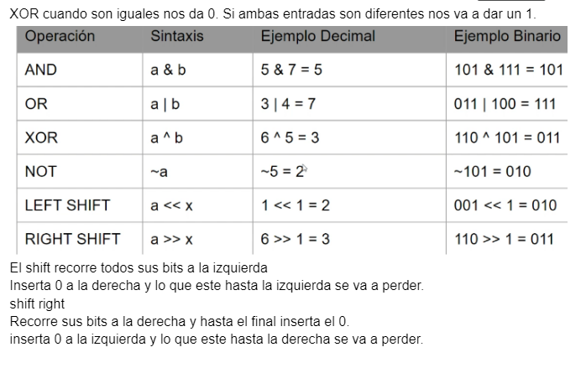

El shift recorre todos sus bits a la izquierda

Inserta 0 a la derecha y lo que este hasta la izquierda se va a perder.

shift right

Recorre sus bits a la derecha y hasta el final inserta el 0.

inserta 0 a la izquierda y lo que este hasta la derecha se va a perder.

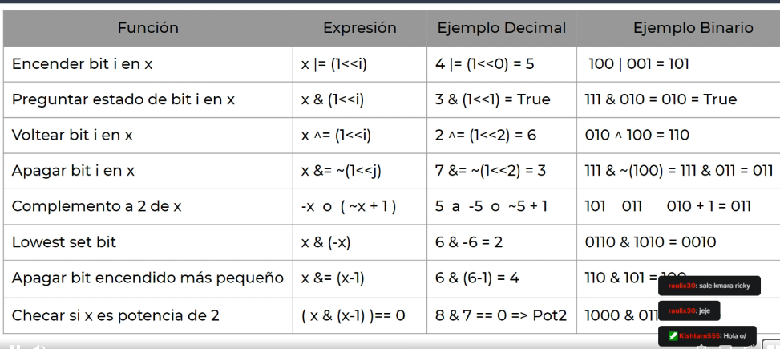

# Math

## Binary Exponentiation

O(log n)

Without modulo.

**Code:**

long long binpow(long long a, long long b) {

long long res = 1;

while (b > 0) {

if (b & 1)

res = res * a;

a = a * a;

b >>= 1;

}

return res;

}

Problem: Compute x^n mod m.

**Code:**

long long binpow(ll a, ll b, ll mod) {

a %= mod;

long long res = 1;

while (b > 0) {

if (b & 1)

res = res * a % mod;

a = a * a % mod;

b >>= 1;

}

return res;

}

## Euler Totient Function

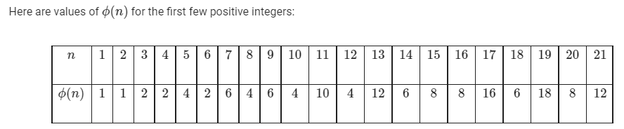

O(sqrt(n))

**Code:**

int phi(int n) {

int result = n;

for (int i = 2; i * i <= n; i++) {

if (n % i == 0) {

while (n % i == 0)

n /= i;

result -= result / i;

}

}

if (n > 1)

result -= result / n;

return result;

}

O(n log log n)

**Code:**

void phi_1_to_n(int n) {

vector<int> phi(n + 1);

for (int i = 0; i <= n; i++)

phi[i] = i;

for (int i = 2; i <= n; i++) {

if (phi[i] == i) {

for (int j = i; j <= n; j += i)

phi[j] -= phi[j] / i;

}

}

}

## Counting Divisors

**Code:**

//Resolvemos para todos los X, y ya después vemos las consultas

//Serie armonica, crece como lógaritmo de n

#include <iostream>

#include <algorithm>

#include <vector>

using namespace std;

int main(){

long long n = 0, aux = 0;

cin >> n;

long long max = 1000000 +1;

vector<int> nums_div(max);

for(int i = 1; i < max; i++){//Recorremos hasta el máx

for(int j = i; j < max; j += i){//Recorremos hasta el max, a partir de nuestro divisor actual, aumentamos al sig divisor.

nums_div[j]++;

}

}

for(int i = 0; i < n; i++){

cin >> aux;

cout << nums_div[aux] << " ";

}

return 0;

}